What the KG wore in the Three Kingdoms Wars Part 2
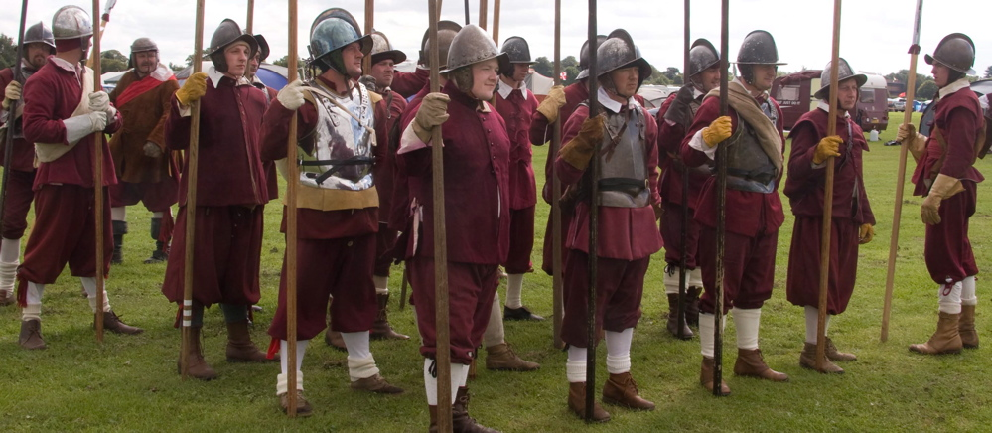

Men

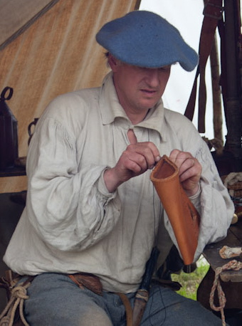
The basic undergarment for all men is the SHIRT. It is a T-shaped, knee length garment made of unbleached linen, with a lot of fabric in the body and sleeves, gathered into cuffs for the sleeves and into a neckband for the body. Large square pieces of fabric are inserted under the sleeves to form gussets White cloth was the prerogative of richer men and dyed fabric far too expensive to waste on shirts. A soldier’s shirt can be of a coarser weave than an officer’s, but they are all basically the same shape. A shirt is cut high to the neck with an upstanding neckband about 2-3cm high and the neck opening should be long enough for the shirt to go over your head and is tied at the top with a single tie or bandstring.

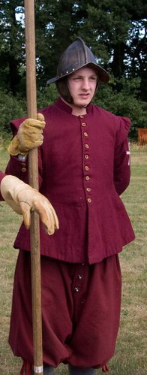
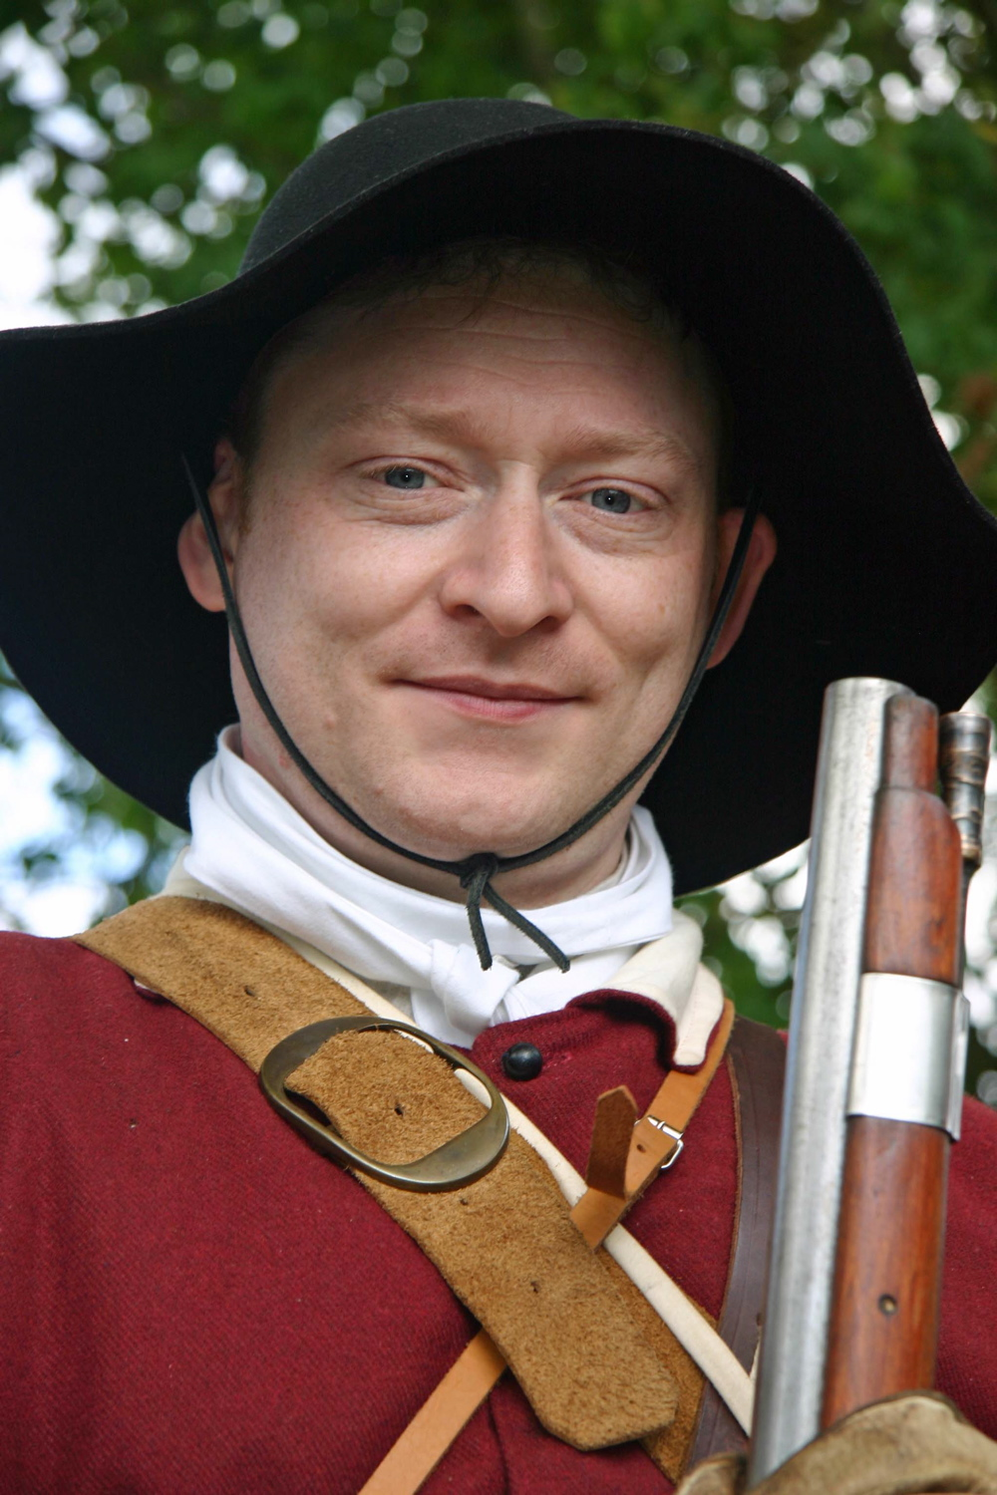
A COLLAR or FALLING BAND is worn with shirts, not part of the shirt, but a separate item. In this period it is a rectangle of linen, long enough to go around the neck of the wearer and varies from a hands width to about 20cm deep. The top long edge is gathered into sewn darts, matching the length to your neck measurement and shaping the band. A second rectangle forms the NECKBAND. One edge is turned over and sewn to the underside of the collar’s top edge. Bandstrings are sewn to the ends. The collar’s band sits inside the shirt’s neckband; the collar itself lies outside any jacket. Both shirt and collar are fastened with ties or laces. For common soldiers a tied length of linen tucked into the coat’s standing collar can also be worn

Over the shirt a DOUBLET, or SOLDIER’S COAT is worn. The coats were made for regiments to common patterns in quantity, so their fit was not exact. As explained in the introduction, the King’s Guard were issued with red coats, of woollen cloth so this is what we should be portraying. The simplest style is a loose-fitting garment with body and tabs cut in one piece and with seams sewn only from neck to lower rib-height. Overall length of doublets, etc. is to the hip, not the thighs like jackets worn today. The upper body section may end above the modern waistline.
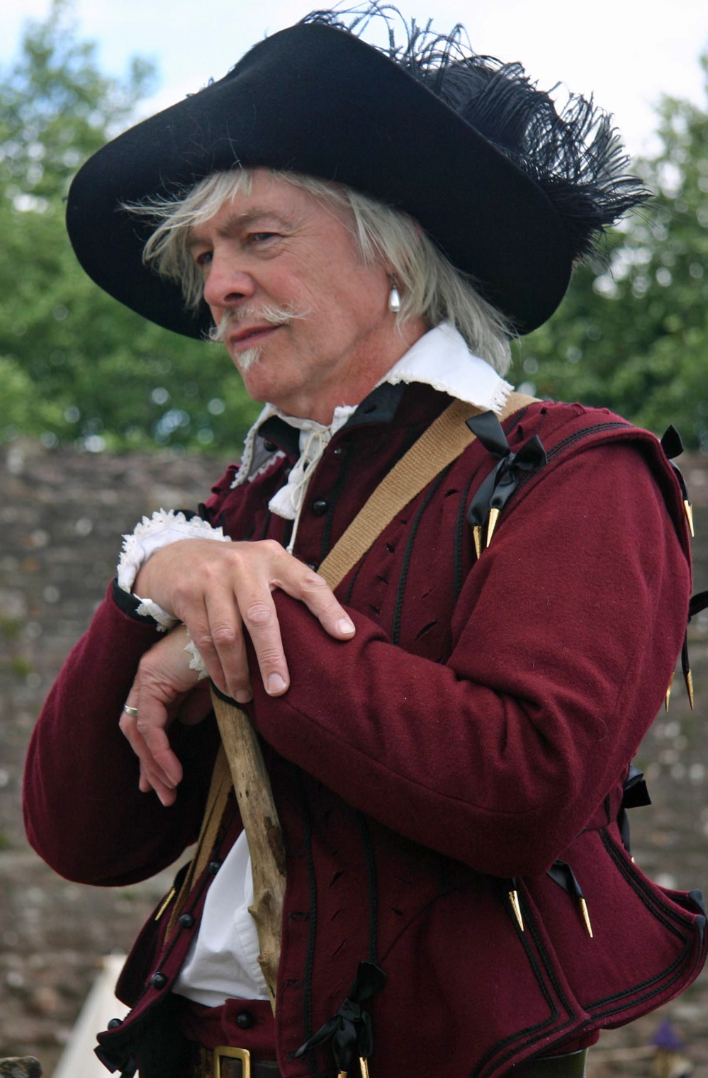
Soldier’s coats were lined or unlined, depending on how much money a Colonel was prepared to spend, but doublets were generally higher quality items and would be lined and tailored to fit and time was taken to finish them properly. Sleeves are close fitting, sometimes with turned-back cuffs and wings over the sleeve tops. Collars are high, stiffened with layers of canvas or pasteboard. For high-waisted styles, you need matching breeches that are longer in the crotch. Coats are fastened down the front with several closely spaced buttons, a dozen at least on a soldier’s coat, more for a doublet. They should be shaped like a ball and shanked but can be made of cloth, pewter or wooden beads wrapped with thread. Cloth buttons are more comfortable on a soldier’s coat if you are going to wear armour over the top.

BREECHES are made from wool cloth, normally using a limited colour range, what were known as sadd colours: brown, grey, dull green etc., although we KG were issued with breeches to match the coats. Style depended on class and geography, unless issued by the regiment. Soldiers from country areas far from the cities, London or Oxford perhaps, wore an old-fashioned shape, full and baggy, button flies and fastened below the knee with ties, or buttons. This earlier style of breeches was often held up by hooks on the waistband that located in eyes on the matching doublet’s inner waistband. In fact it can be argued that one of the main reasons for wearing a doublet was to keep your breeches up, although during the war many of these kinds of nicety were quickly forgotten. The earlier fashion of tying the two together with points and ribbons had all but died out. As a result, 17th Century breeches will look saggy-bottomed when you stand upright.

A more modern style, worn by townsmen and possibly copied for regimentally supplied breeches, has narrower legs, but is still quite saggy. The legs can be gathered to a band and buttoned as before or just hemmed and left ungathered, the so-called unconfined style. Both styles may have POCKETS in the side seams at the hip. Surviving pockets from the period are simple leather bags, though linen works just as well.

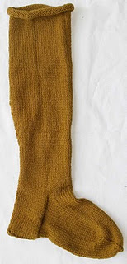
HOSE are worn to just around the knee. A contemporary pattern describes a knee high stocking, turned down over a tied garter. You can buy or (get someone to) knit your own woollen HOSE. A good modern substitute is plain woollen tights or unribbed knitted stockings in any of the drab colours mentioned in the introduction. Shaped linen or cloth hose are also worn. Hose should be held up by GARTERS, either strips of cloth, or knitted.

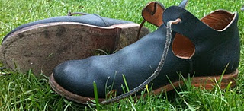
Low-heeled LATCHET SHOES were worn by most common people and issued to soldiers in the wars, although mounted officers and cavalry troopers wear boots. A closed shoe or ankle-boot referred to as a STARTUP can also be worn as a more protective alternative. No clear evidence has been shown for their issue by armies in Britain during this period, though they were common for rural folk so they can’t be ruled out for soldiers.

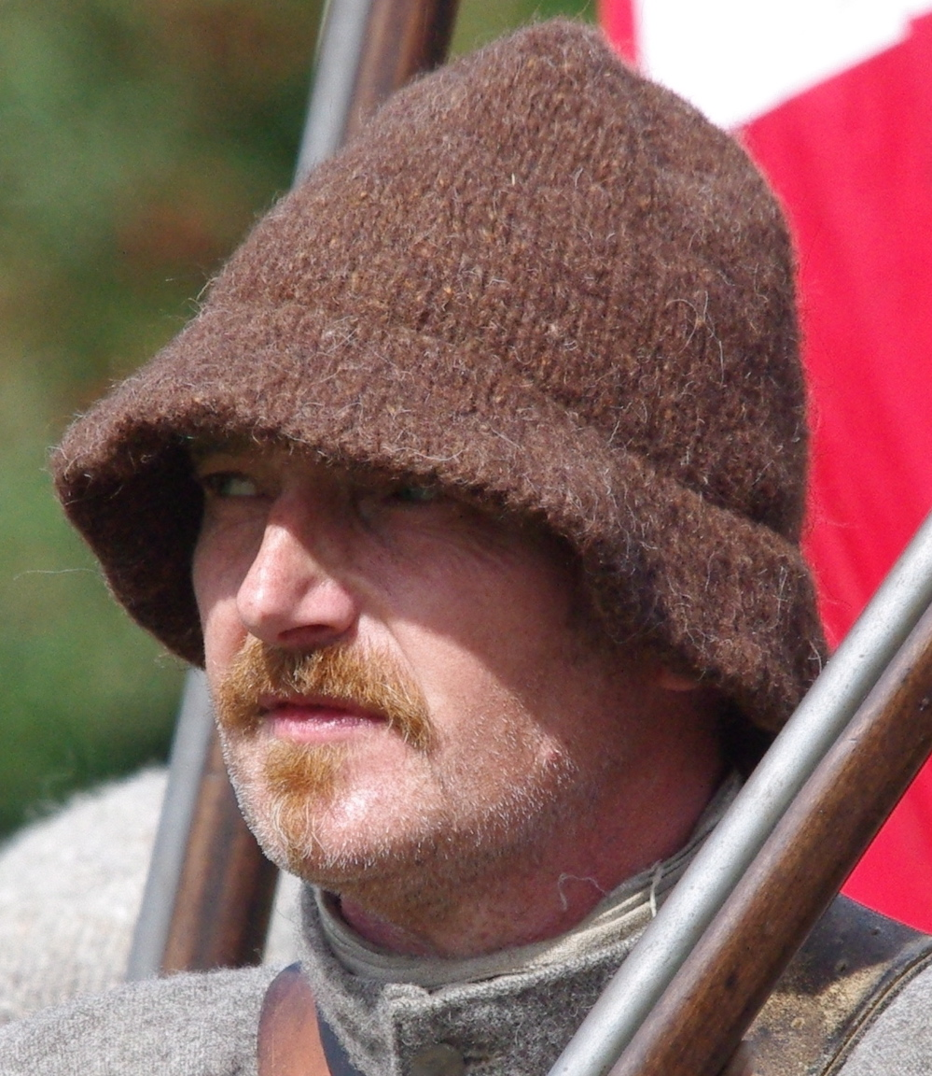
Men of all ages kept their heads covered almost all the time. HATS or CAPS were doffed when you met anyone of higher social status or rank or were being polite. For the battlefield, headgear is determined by your fighting role. Pikemen wear morion helmets and musketeers a hat, cap or bonnet. The simplest is the MONMOUTH CAP, a style of knitted woollen cap, heavily felted. It may have been a fairly high conical shape with or without a brim round the edge.

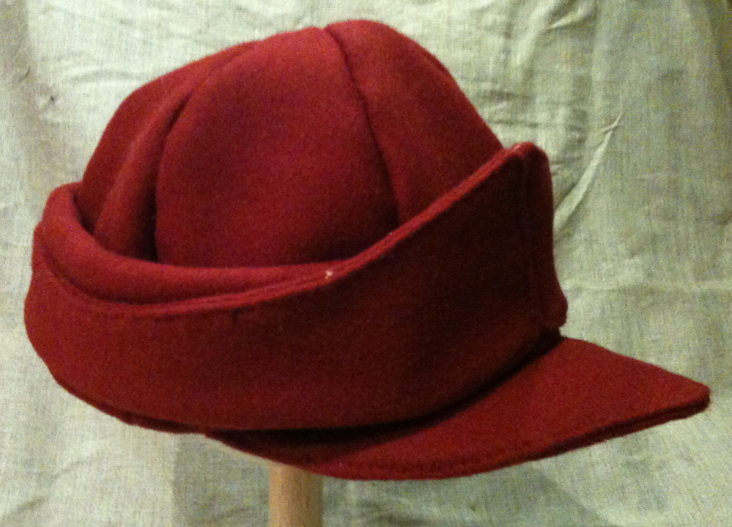
MONTEROS were issued with coats and breeches to Oxford soldiers (us) in 1643. A Montero is a peaked cap made of segments of woollen cloth with a skirt running around the edge that can either fold down for protection in bad weather or up for a stylish peak. Broad-brimmed HATS are also worn, either made from blocked and felted wool/fur or leather.

To summarise, a soldier’s basic costume, regardless of the fighting arm chosen or the Army that you join, consists of a SHIRT, a pair of BREECHES, a COAT (or DOUBLET), HOSE, SHOES and a HAT. The coat or jacket will be of a colour and cut chosen by the colonel who raised the original Civil War regiment. Sometimes, this applies also to breeches and, occasionally hats. Your regiment will provide relevant details. Shoes, hose and hats can be bought from traders. Some soldiers carry sausage shaped SNAPSACKS, worn across the back from shoulder to hip with a strap diagonally across the chest. CLOAKS or a length of ragged wool or leather for use as a CAPE in the rain may be worn in poor weather but only off the battlefield if portraying soldiers “on campaign” or on guard duty with permission.

Further information, features, articles and pictures of clothes from the 1640s can be found on this website
http://thegoodwyfe.blogspot.com

Thanks to Alan Mackinnon, John Beardsworth, Rusty Aldwinckle and Facebook for photos.

Gillian Thomson & Ian Dicker December 2011

